**Task 1**

1. Create a new project called **surname name (your surname and name).**
2. Set the project start date - 2021-01-22.
3. Set the project working time:

* 30 hours per week, 6 hours a day, 20 working days per month,
* Working time on Tuesday -Friday from 9.00 to16.00 hours, lunch break from 13.00 to 14.00 hours;
* Working time on Saturday from 9.00 to 15.30 hours, lunch break from 12.30 to13.00 hours;

On Monday and Sunday nonworking days.

* Enter the public holidays: 2021-07-06, 2021-08-15 and 2021-11-01

1. Enter the project tasks and their durations (using the shortest state abbreviations for the task durations):

| **Task title** | **Duration** |
| --- | --- |
| 1. Start | 0 days |
| 1. Planning |  |
| * 1. Determination of the content of advertising | 2 weeks |
| * 1. Preparation of the sketches for illustrations | 4 days |
| 1. Preparation of the materials |  |
| * 1. Text writing | 3 weeks |
| * 1. Text translation into English | 1 week |
| * 1. Text translation into French | 1 week |
| * 1. Creation of illustrations | 7 days |
| * 1. Editing | 1 week |
| * 1. Typesetting of the text and layout | 7 days |
| * 1. Layout of the cover | 2 days |
| 1. Preparing for the publication |  |
| * 1. An adjustment | 1 week |
| * 1. A matching colours | 2 days |
| * 1. An ordering of the publishing | 2 day |
| 1. Publishing | 1 week |
| 1. Finish | 0 days |

1. Structure the project plan, indicating the levels of the tasks (create a hierarchical task structure). Number the tasks.
2. Indicate that the tasks 1 and 5 are the project milestones.
3. Set correlation type between the task Finish to Start:

1🡪2🡪3🡪4🡪5🡪6; 2.1.🡪2.2.

3.1. 🡪3.2. 3.1🡪3.3.

3.1. 🡪3.4. 3.2.🡪3.5.

3.3. 🡪3.5. 3.4. 🡪3.5.

3.5🡪3.6. 🡪3.7. 4.1.🡪4.2.🡪4.3.

1. Set type connection Start to Start to the tasks: 3.2. 🡪 3.3; 3.3 🡪3.4.
2. Specify the tasks overlap in two days’ time of the tasks: 3.1. 🡪3.2., 3.1🡪3.3., 3.1. 🡪3.4.
3. Before the end of the project insert 1 hour duration repeating task “Meeting” which will be held every Thursday during all the project.
4. Enter the resources, assign the resources to the tasks:

| **Title of the resource** | **Assign to the task** | **Payment rates and methods** |
| --- | --- | --- |
| Project Manager | Assign to the all project meetings | 45 EUR- standard |
| Writer | Determination of the content of the publication, Text writing | 500 EUR in the end of work for the accomplished work. |
| Translator1 | Text translation into English | 450 EUR in the end of work for the accomplished work. |
| Translator2 | Text translation into French | 450 EUR in the end of work for the accomplished work. |
| Designer | Preparation of the sketches for illustrations, creation of the illustrations,  A matching colours | 20 EUR – standard, 25 EUR – for the overtime. |
| Paste-up artist | Typesetting of the text and layout | 12 EUR– standard, 15 EUR - for the overtime. |
| Editor | Editing | 12 EUR – standard, 15 EUR - for the overtime. |
| Corrector | An adjustment | 15 EUR – standard, 19 EUR - for the overtime. |
| Paper | Determination of the content of advertising. Assign 2 items. | 3,50 EUR - 1 item |

1. If it’s needed, resolve the resource conflicts.
2. Enter fixed costs (expenditure) to the tasks

|  |  |
| --- | --- |
| **Task title** | **Fixed costs, EUR** |
| Text writing | 75 |
| Text translation into English | 120 |
| Text translation into French | 100 |
| Creation of illustrations | 200 |
| Typesetting of the text and layout | 100 |
| Layout of the cover | 250 |
| Publishing | 2000 |

1. Highlight the project's critical path.
2. Save the project baseline.
3. Turn on the project summary row.
4. Create word document named **surname name (your surname and name)** in which:
   1. 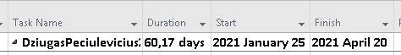**Specify the project duration, start and end day.**
   2. **Specify the project total cost**.
   3. **Specify how much cost *Text writin*g task.**



* 1. 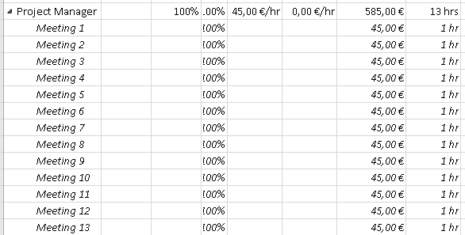**Specify details how much you have to pay for Project manager**.
  2. 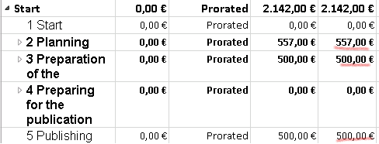**Specify the cost of each task in the project.**
  3. 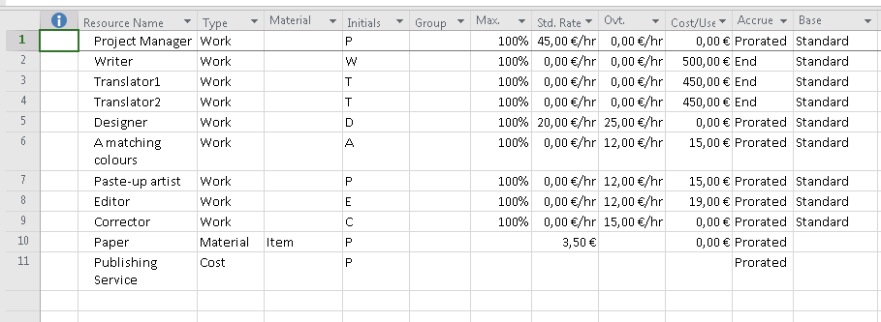**Specify how much you will have to pay for each resource on the project**.

1. Indicate the tasks completion rate:

|  |  |
| --- | --- |
| **Task title** | **Task implementation, %** |
| Determination of the content of advertising | 100 |
| Preparation of the sketches for illustrations | 100 |
| Text writing | 100 |
| Text translation into English | 50 |
| Text translation into French | 25 |
| Creation of illustrations | 50 |

1. In the Resource Sheet select the options to indicate the cost of each resource in the project.
2. Correct The Gantt Chart so, that the print image would fit on one sheet, type your name and date in the margin.
3. In the Gantt Chart view set the columns to display the prices and the form to show the working time of the resource.
4. Archive your folder **Surname name (your surname and name**) and upload into Moodle.